Phys 203 Lab 2 Procedure

Nicholas Pun

27872167

Lab 2 Procedure: Fourier Transformations

* In this lab, our goal is to develop an understanding of Fourier Transformations and Transfer Functions.
* To do so, we will need to measure and analyze the output of the Fourier Transformation after applying it to various inputs such as sine waves, square waves, and triangle waves.
* Two important equations we explore during this lab are:

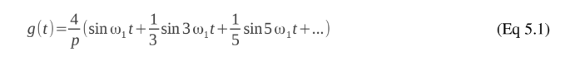

* while exploring square waves, and

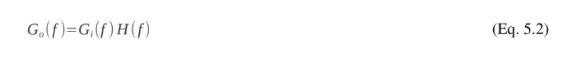

* while exploring the Transfer Function.
* The equipment we used during this lab are as follows:
* Oscilloscope (Keysight InfiniiVision DSOX2012A)
* Function Generator (Rigol DG 2021)
* Computer
* Spring attached to two speakers
* One speaker provides driving signal, other speaker detects output signal
* Whole apparatus placed in sound-reducing insulated container
* The following image is a schematic diagram of the set-up:

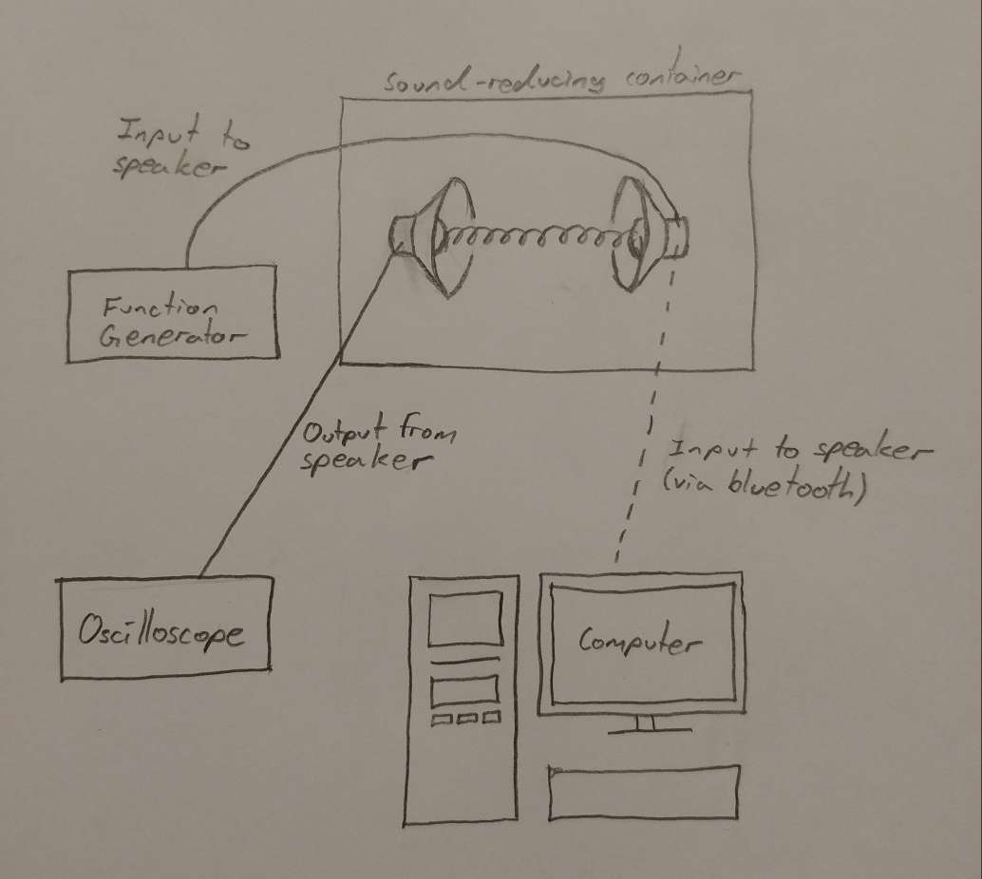

* We begin the experiment by exploring what the Fourier transform produces given an input of:
* a sine wave to see a single peak at the input frequency,
* a larger sample of input data to see that the peaks narrow,
* a square wave to see many peaks at intervals twice the input frequency and decaying amplitudes, and
* a triangle wave to see the same peaks as the square wave but with a faster decay.
* We then explore three ways to establish the Transfer Function by:
* inputting white noise since the Fourier spectrum is completely flat and thus $G_{o}(f)=H(f)$,
* inputting a sharp impulse since $G_{o}(f)=H(f)$ for this as well, and
* inputting a sine wave at various frequencies to find the points of local maximum response match with the peaks of the two previous methods.
* We lastly explore one use of the Transfer Function by:
* inputting a square wave at a frequency of one of the peaks to see that its output becomes sinusoidal since the Transfer Function and Fourier Transform only share a common peak at the input frequency.